Southwest Minor Hockey Association Tournament Convener

* Entry fee: $300.00 Tyke $600.00 Novice
* 2 divisions (only local league/house league teams shall apply)
* 3 Game Guarantee
* Souvenirs for each player
* Off ice games and entertainment
* Food, vendors and raffle prizes
* Admission: $5.00 weekend gate passes (students and children are free)

Contact: Jim Hamilton [Hamilton-j@hotmail.com](mailto:Hamilton-j@hotmail.com)

Mobile: 519-330-6197

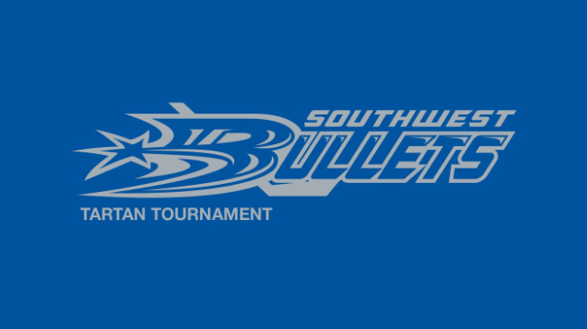

Venue: Glencoe/Bothwell Arenas

**Southwest Bullets Memorial Tournament**

**TYKE/ NOVICE LL devisions**

Dave Waller Memorial Tyke Fun Day

John Horvat Memorial Novice LL Tournament



ATOM/PEEWEE LL Tartan Tournament

**January 28-30, 2017**