QUARTER AUCTION

WHEN: Thursday, June 16, 2016

WHERE: Glencoe Legion (156 McRae St.)

Doors open at 6:00, Auction begins at 7:00.

$5.00/ticket (gets you 1 paddle) Additional paddles can be purchased at the door for $2
Advanced tickets only, can be purchased from any of our vendors or Wendy Gould 519-287-1103, Mary Ann McAlpine 519-871-5393
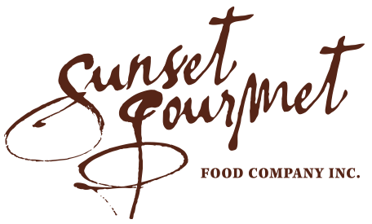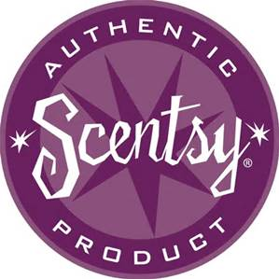
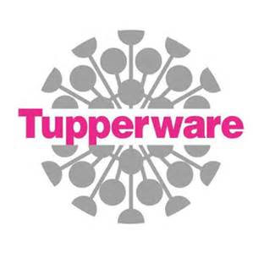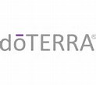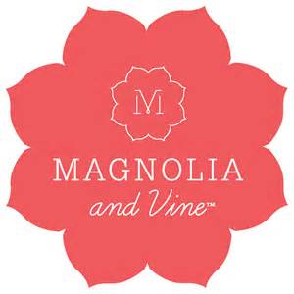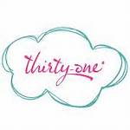
COUPONING WITH CHERYL 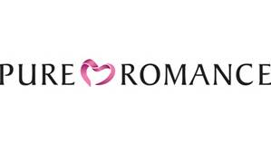……. AND MORE!
AGE OF MAJORITY EVENT.

