Venue: Glencoe/Bothwell Arenas

* Entry fee: $600.00 per team
* 2 divisions (only local league/house league teams shall apply)
* 3 Game Guarantee
* Souvenirs for each player
* Off ice games and entertainment
* Food, vendors and raffle prizes
* Admission: $5.00 weekend gate passes (students and children are free)

Contact: Jim Hamilton [Hamilton-j@hotmail.com](mailto:Hamilton-j@hotmail.com)

Mobile: 519-330-6197

**Southwest Bullets Tartan Tournament**

Atom/ Peewee LL devisions

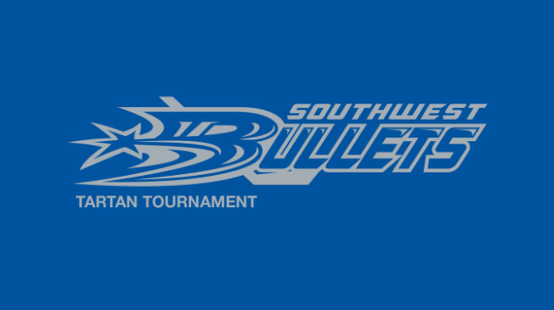

ATOM/PEEWEE LL Tartan Tournament

November 25-27, 2016

Southwest Minor Hockey Association Tournament Convener